

FPT-aptech computer education

**Report eProject**

**News and Reporting**

***Batch:*** T2307A

***Semester:*** 1

***Course:*** ePRJ

***Group: 2***

***Members:***

1. Dang Hong Quan -  QuanDHTH2304004@fpt.edu.vn

2. Do Thi Diep Quyen -  QuyenDTDTH2307007@fpt.edu.vn

3. To Xuan Bach - BachTXTH2307033@fpt.edu.vn

4. Nguyen Anh Ngoc - NgocNATH2307029@fpt.edu.vn

***Instructor:*** Nguyen Duy Hoang

**Table Of Content**

**1.** **Introduction** 3

**2.** **Problem Statement** 4

***2.1 Problem Abstraction:*** 4

***2.2 Requirement Specification:*** 5

**3.** **Site Map Of The Website** 6

**4.** **Use Case** 7

**5.** **Flow Chart** 8

**6.** **Main Screens Of The Website** 12

**7.** **Hardware/ Software Requirements** 15

***7.1*****Hardware** 15

***7.2*****Software** 15

# **Introduction**

The thirst for learning, upgrading technical skills and applying the concepts in real life environment at a fast pace is what the industry demands from IT professionals today. However busy work schedules, far-flung locations, unavailability of convenient time-slots pose as major barriers when it comes to applying the concepts into realism. And hence the need to look out for alternative means of implementation in the form of laddered approach.

The above truly pose as constraints especially for our students too! With their busy schedules, it is indeed difficult for our students to keep up with the genuine and constant need for integrated application which can be seen live especially so in the field of IT education where technology can change on the spur of a moment. Well, technology does come to our rescue at such times!!

Keeping the above in mind and in tune with our constant endeavor to use

Technology in our training model, we at Aptech have thought of revolutionizing the way our students learn and implement the concepts using tools themselves by providing a live and synchronous eProject learning environment!

# **Problem Statement**

## ***2.1 Problem Abstraction:***

DNBC is an established name News and Reporting. They have their network of

reporters across the world.

They collect and send all news articles to the main office in London.

Main Office then prepares the news and publish it in newspaper in respective

segments.

To make news available in faster to the readers and subscribers, now company is

planning to launch a website. This will help in bringing information and news faster

and also readers can search and read news from any location.

The website which they demand is suppose to provide user friendly environment and

navigation. The important menu must be stated in the top section of the webpage.

Also a decent look out and color combination is expected.

The website is to be developed for the Windows Platform using HTML5, JavaScript

and Geolocation. The site should work well in all leading browsers including Chrome,

IE, Firefox etc.

.

# 

## ***2.2 Requirement Specification:***

Requirement Specification:

The Web site is to be created based on the following requirements.

1) The Home Page with headlines and other major activities happened should be

provided. (Also navigational link must be included.)

2) The website must provide information like “About us”, “Today in World”,

“Sports”, “Business”, “Contact us” etc.

3) Each section must provide proper listing of news along with brief information.

4) Also each link must be properly hyperlinked, images must be used wherever

necessary.

5) Facts and figures related to News should be provided.

6) Contact Us page must flash the address and location on map of the offices of

DNBC.

7) Individual pages for various sections of news should be provided with detailed

information and images.

8) Top Cities of the World (Atleast 5) should have separate page with some

information about various activities happening in those cities.

9) All locations should be displayed using Maps (Geolocation).

10) Feedback must be taken on the information available on website

# **Site Map**

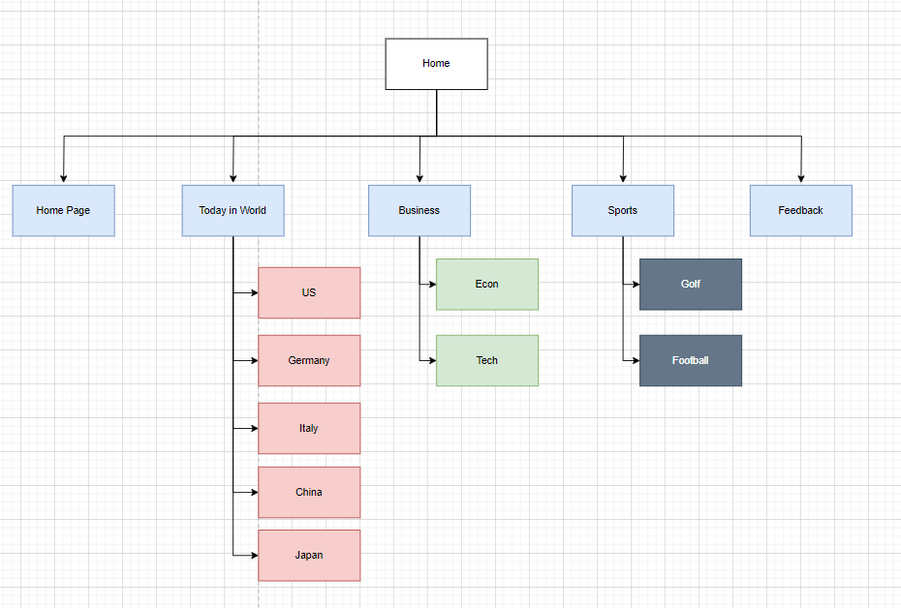

# **Use Case**

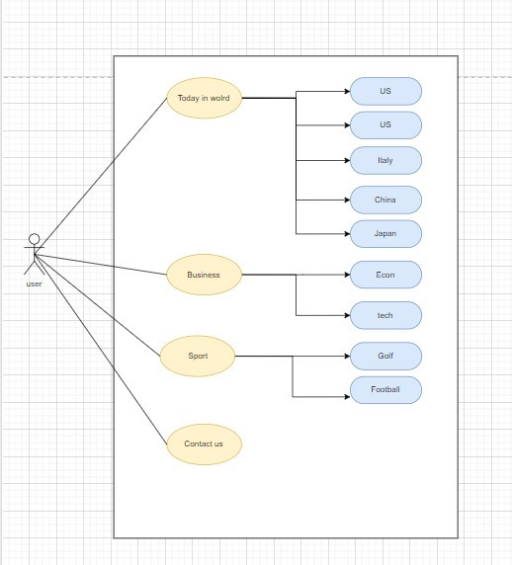

# **Flow Chart**

**1.Today in World**

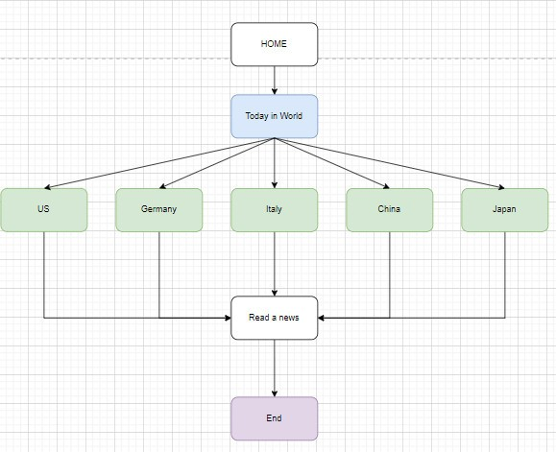

2.Sport

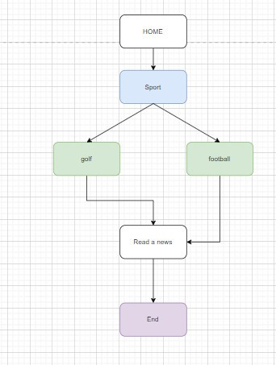

3.business

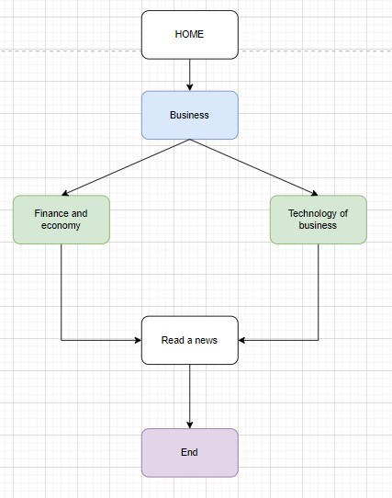

4.feedback

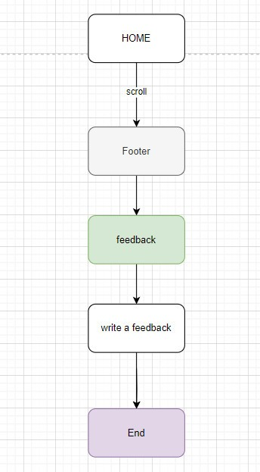

# **Main Screens**











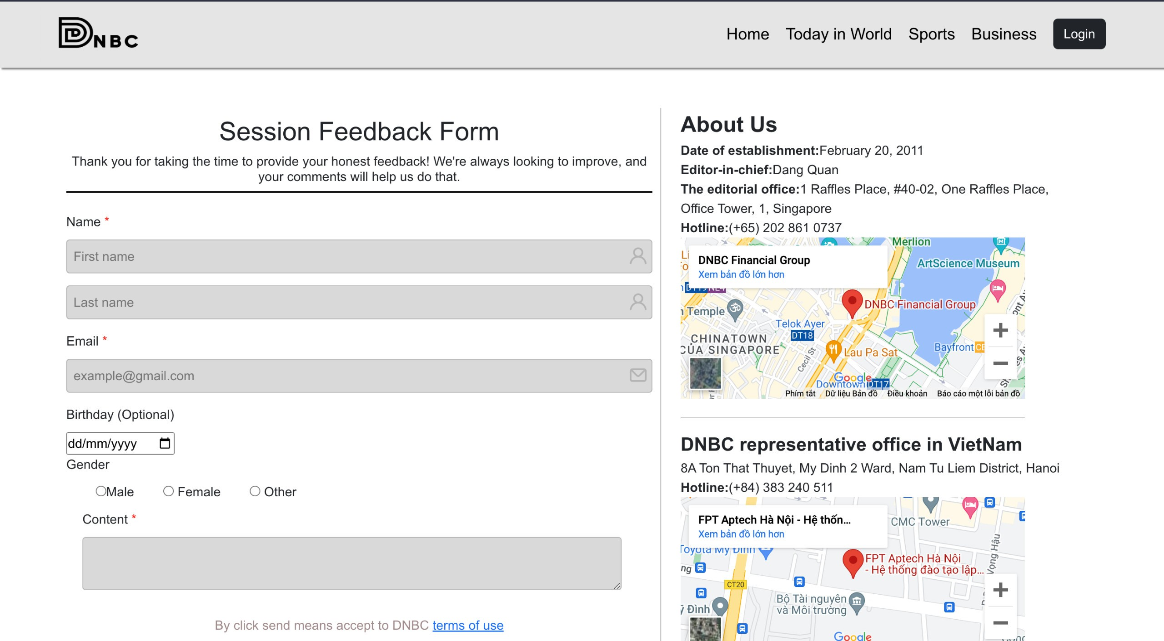

# **Hardware/ Software Requirements**

**Hardware**

* A minimum computer system that will help you access all the tools in the courses is a 1 ghz processor(about Intel Celeron or better)
* 512 MB RAM or better
* 1 GB Disk Space.

## **Software** **[Either or Combination as per Course/Sem]**

• Sublime Text/Notepad++ / Visual Studio Code

• React JS / Bootstrap /HTML CSS/ JavaScript

• Figma

• Chrome / FireFox / MS Edge /Brave/ Opera /Safari